**Analyzing Location and Shot Type to Improve Scoring**

**Literature Review**

When people think of mentors or role models, they typically look for a person who has already accomplished what they wish to have. Sometimes what people fail to realize is that in sports, a team can be a mentor. This was the case for the Oakland Athletics and the snowball effect of *Moneyball*. In an article from NBC, Billy Beane, the general manager behind *Moneyball*, is quoted to say, “I do think it accelerated, to some extent, the analytics revolution,” (2021). After *Moneyball*, many teams across multiple sports developed an analytics team, and even businesses have modeled some of their methods after those of the Athletics. The goal of hockey is to score more goals and win games, so why not look at teams that have scored more goals and imitate what they have done?

HockeyViz is a website that has multiple articles regarding hockey research, one of which is written by Micah Blake McCurdy and is titled, “Standardized Goals Against,” (McCurdy). This article attempts to statistically explain why some shots are harder than others. In his article, one of the directions he names for further research is an analysis of shot types.

By looking at the team that scores most frequently, an approach to scoring can be modeled. By looking at the ways that team scores, both in terms of location and shot type, coaches and players receive information of where to take shots, and what kind of shot to take. Players and coaches can then implement training strategies to increase the amount of these shots, which should increase their number of goals scored, which can further increase their wins. Goalies can also use this information to train against these shot types, allowing them to save more shots. This would lower an opposing team’s goals, making it harder for their opponents to win.

**Methods**

**Participants and Design**

The data set for the women’s games was chosen because it focused on multiple teams, meaning there was less bias in the data set. By using modeling and exploratory data analysis, I aimed to create a plan for teams to take more successful shots and put themselves in the position to take these shots.

**Procedure**

To identify which team others should model after, I found the team who had the highest goal percentage, the Clarkson Golden Knights. This was found by dividing a team’s goals by their total shots. I chose this approach over choosing whatever team had the most goals because the number of events per team varied by thousands, so total goals differed significantly too. Goal percentage describes how often a team scores relative to how many shots they take. This eliminates the bias of the data completely, allowing me to compare the teams at an equal level.

After finding that the Clarkson Golden Knights had the highest goal percentage, I created hexbin charts to show where they took more shots, and a hexbin chart of where goals were scored. I created these same hexbin charts for the other teams to demonstrate where they shot and scored comparatively to the Golden Knights. I then created a bar graph of shot types used on goals, faceted by team, to represent how shot type differs by team.

In analyzing the location of shots taken, it is important to note that shots close to the goal are defined as when the x-coordinate is between 165 and 190, the middle of the offensive zone is defined when the x-coordinate is between 145 and 164, and the back of the offensive zone is defined when the x-coordinate is between 120 and 144. A player is considered close to the boards when the y-coordinate is within ten units of the boundaries of the y variable.

**Results**

Goal percentage is a measure of success that tells how often a team scores relative to the number of shots they take. Ranking the teams from greatest to least, I found that the Clarkson Golden Knights had the highest goal percentage, followed by the Finnish Olympic team, St. Lawrence Saints, Canadian Olympic team, U.S. Olympic team, and then the Russian Olympic team. Realizing the Golden Knights had the highest goal percentage in the available data set, I focused on analyzing their methods, and how they are different from other teams in terms of location and shot type.

By analyzing the Golden Knight’s hexbin chart, I found that they took most of their shots near the center of the ice and the offensive zone, or close to the goal, with a few shots occurring near the boards.

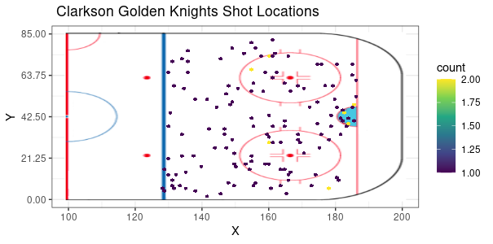

The Canadian and U.S. Olympic teams seemed to have similar approaches. Both teams play close to the goal, especially the Canadian team. As indicated by their chart, there are a plethora of locations close to the goal where multiple shots are taken. The U.S. team has many shots close to the goal as well, but not as many. Both teams also seem to venture out towards the middle of the offensive zone and close to the boards.

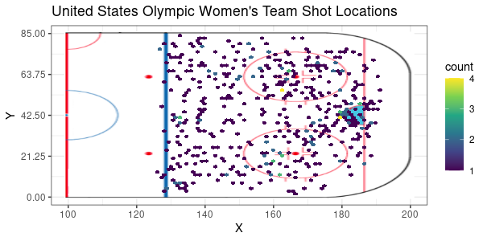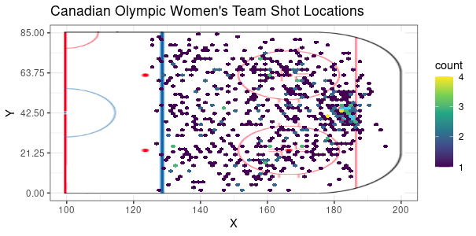

Interestingly, the team with the second highest goal percentage, the Finnish Olympic team, has a different approach. While several of their shots are close to the goal, once they are away from the goal, they tend to take significantly more shots near the boards and to the middle/back of the offensive zone.

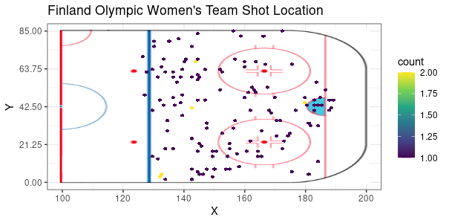

The teams with the third highest and the lowest goal percentage, the St. Lawrence Saints and the Russian Olympic team, respectively, seemed to follow this strategy.

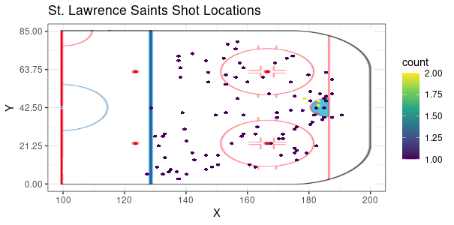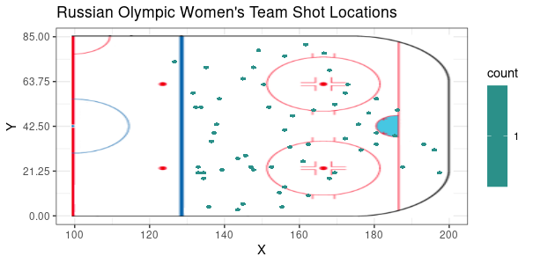

By analyzing where the Golden Knights scored, I found that all of their goals were scored close to the goal and most were close to the center of the ice. Since the Canadian and U.S. Olympic teams had a similar scoring approach, it is natural for them to follow this same tendency, with a few differences due to quantity of data entries.

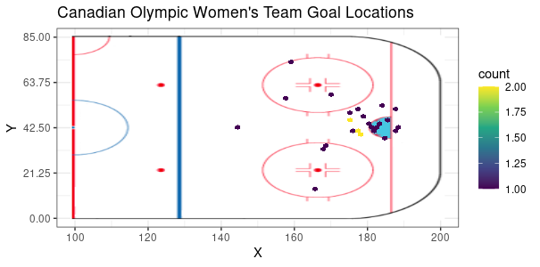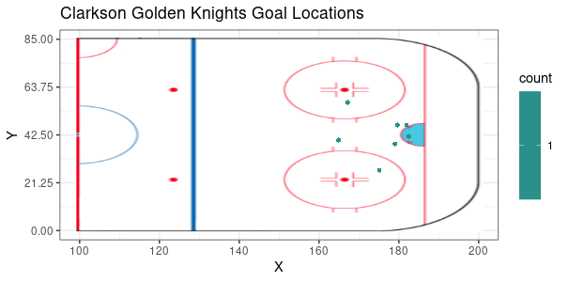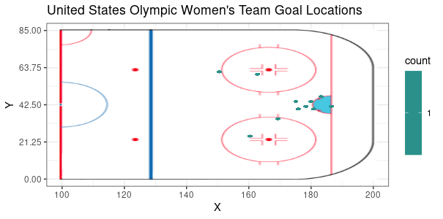

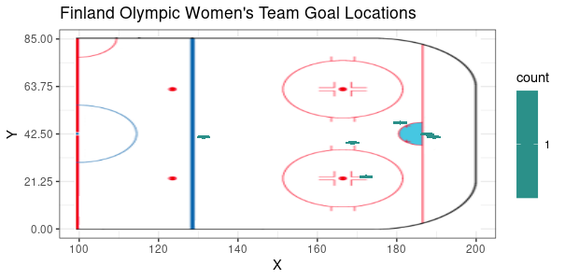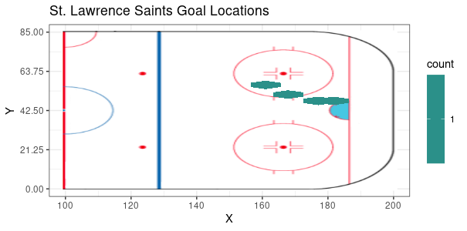The Finnish Olympic team scored most of their goals in the center of the ice and close to the net. The St. Lawrence Saints had a similar trend in scoring their goals, but, interestingly, the Russian Olympic team scored no goals.

By examining shot types of each team’s goals, I found that most goals for the Golden Knights came on wrist shots, while every other team scored on snapshots, except for the St. Lawrence Saints who scored once on each shot type. The Canadian Olympic team scored on more wrist shots relative to the other teams.

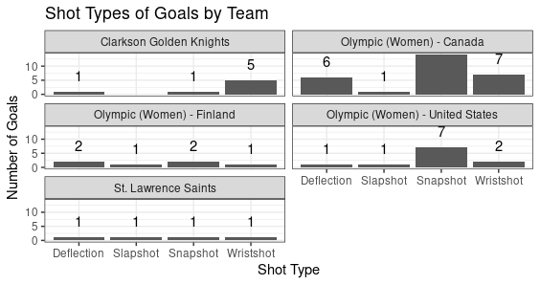

**Analysis**

Looking at the Golden Knights’ approach to scoring is incredibly important. By analyzing their hexbin charts, it was found that they scored more when playing close to the net and taking wrist shots. Playing close to the net seems to be a common theme among the analyzed teams, however it seems that wrist shots are not stressed nearly as much among other teams.

The Canadian Olympic team, following a similar approach, shot more wrist shots relative to the other teams. Given that they were a largely successful team, the data demonstrates that playing close to the net and taking more wrist shots could be beneficial to other teams.

The team with the second highest goal percentage, the Finnish Olympic team, seems to have a very different game plan, where they tend to shoot away from the net and tend to score close to the net, and relied on snapshots and deflections for them to score. This contradiction in shooting and scoring locations is very interesting because it seems as though they are not shooting where they typically score. I do not believe their approach will have accurate results as deflection shots ricochet off someone and go into the net—they are not the player’s original intent. This lack of accuracy can explain how the St. Lawrence Saints had different locations for goals, and how Russia scored no goals. In a sense, this kind of shot can be considered a “happy accident” where a team almost accidentally scores.

Something to note about the data is that the Golden Knights had less data than other teams, which could impact this project’s results. Considering that the Canadian Olympic team had a lot of success playing with a similar style, and they had the most data, I still believe these results are valid. Had the Golden Knights had more data entries, each of their shot types would have risen, including wrist shots and slapshots. Given that the Canadian team had a lot of success with the wrist shot relative to other teams, I believe the wrist shot to be crucial to scoring.

**Conclusion**

Teams who attempt to shoot more when close to the goal tend to score more, and the wrist shot seems to be very important to scoring. These things could lead to the goalie having less time to see and react to the puck, leaving the net open to score on.

While data may have been limited for the Golden Knights, I still believe modeling after their scoring approach could be prudent for teams. The Canadian Olympic team had a lot of success with a similar scoring approach, and most of the data in the data set was theirs. For this reason, it could prove important to repeat this analysis with a larger data set that could include more teams and more data for each team. Should similar results be found, other teams could more confidently model their scoring approach after that of the Golden Knights.

Every shot in hockey is different and there are more factors that come into play than shot location and shot type. For future studies, I recommend either using a model with a different predictor, or multiple predictors such as location, shot type, whether there was traffic, and skater ability. While further research could prove beneficial to accommodate for the recommendations that I have, this analysis of scoring proved beneficial in guiding teams to play near the net and attempt to take more wrist shots.

**References**

2021 Comcast SportsNet. (2019, July 25). *Billy Beane explains how A's, 'Moneyball' sped up MLB analytics revolution*. RSN. https://www.nbcsports.com/bayarea/athletics/billy-beane-explains-how-moneyball-sped-mlb-analytics-revolution.

McCurdy, M. B. (2017, May 31). HV Article. https://hockeyviz.com/txt/sGA.